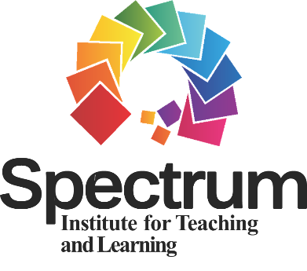
SITL Mini Grants for
International
Presentations

Application Packet
DIRECTIONS: The Application Packet includes three parts: PART 1, the application form (personal and conference information); PART 2, the presentation abstract; and PART 3, the PowerPoint. Please submit each of the three PARTS electronically, each as a separate document.

PART 1: Application Form (SUBMIT AS A SEPARATE DOCUMENT)

1. Category (check one)
Master’s Degree Student
Doctoral Degree Student
Faculty
School Teacher
Coach
Other – please explain:

2. Title of Presentation (10-word limit)

3. Principal Author
Name:
Position/Title:
Affiliation:
Address:
Telephone:
Email:

4. Other Contributing Author(s) (provide the information below for each contributor)
Name:
Position/Title:
Affiliation:
Address:
Telephone:
Email:

5. International Conference Information
Location of Conference (city and country):
Title/Name of Conference:
Dates of Conference (days, month):

6. Type of Presentation (check one)
Oral
Poster
Round-table
Other (please explain):

7. Will you be presenting LIVE onsite at the international conference or will you be presenting ONLINE? Check one of the answers below.
Presenting LIVE Onsite
Presenting ONLINE

PART 2: Presentation Abstract (SUBMIT AS A SEPARATE DOCUMENT)
Please submit the presentation abstract requested by the conference organizers or an abstract crafted around the presentation criteria identified below. We are not identifying a maximum word count for your abstract as different conferences may have different word count limits/abstract requirements. DO NOT include any personal information in the presentation abstract (to facilitate blind review).

PART 3: PowerPoint Presentation (SUBMIT AS A SEPARATE DOCUMENT)
The PowerPoint presentation is requested to supplement the information provided in the presentation abstract. The PowerPoint presentation will aid reviewers in making a more informed decision about your application packet. DO NOT include any personal information in the PowerPoint presentation (to facilitate blind review).

EVALUATION OF ABSTRACTS AND POWERPOINTS

Abstracts and PowerPoints will be peer-reviewed by two Spectrum experts using the following criteria:

Evaluation Criteria for PRACTICAL Presentations
1. Primary goal(s) or objective(s) of the presentation;
2. Who the presentation is for (i.e., school teachers, physical education teachers, coaches, etc.);
3. Description (clear and specific) of what the presentation is about (description of content);
4. Description (clear and specific) of how the content presented can be used by the participants; and
5. Clarity of writing.

Evaluation Criteria for RESEARCH Presentations
1. Purpose and research questions and/or hypotheses;
2. Background literature and theoretical framework as applicable to the research study;
3. Proposed study design and methodology (participants, research design, data collection, data analysis) as applicable to the research study;
4. Potential to contribute to and/or impact Spectrum research (i.e., significance of research study); and
5. Clarity of writing.
• • • • • • • • • • • • • • • • • • • • • • • • • • • • • • • • • • • • • • • • • •

SITL Mini Grant Award Recipients

Please note the following requests from all SITL mini grant award recipients:

• Award recipients must send a copy of the official letter of acceptance (abstract accepted for presentation) provided through the international conference organizing committee once received. Your award will NOT be forwarded to you until the SITL receives a copy of this letter.

• Award recipients must include in their presentation the following statement (acknowledgement):

“This presentation was supported by funds received from the Spectrum Institute for Teaching and Learning.”

• Award recipients must forward a headshot (picture) for posting on the SITL Website and Face Book Page.

• Award recipients must also include proof that their university/institution/school is a non-profit organization. For U.S. based institutions, that is the EIN (Employer Identification Number). For institutions based outside of the U.S., we will require documentation with the institution’s letterhead stating that it is a non-profit institution.

Apply Now for Conferences in 2024

We are currently accepting Application Packets for International conferences scheduled to take place any time in 2024.

Email your Application Packet
(PARTS 1, 2, and 3 as separate documents) to:
Autumn Rosencrantz, SITL Executive Director
rosencrantz.work@gmail.com

